OPLS 10.13.2014- final version

Q3 University of California at Berkeley
CONSENT TO PARTICIPATE IN RESEARCH
My name is Don Moore, I am a professor at the Haas School of Business at the University of California at Berkeley. I would like to invite you to take part in my research study which examines how people estimate.
If you agree to take part, you will be asked to respond to a short survey. You will be asked to estimate some values. The entire exercise should take less than thirty minutes and you will be entered into a performance based lottery for one of several $50 prizes. Your contact information will be collected so that we may compensate you if you have won.
There is no direct benefit to you anticipated from participating in this study. However, it is hoped that the information gained from the study will help us better understand how people learn to make better forecasts, what questions are best for eliciting problems, what training interventions are most helpful, and which aggregation techniques are most effective for maximizing accuracy. There is little risk to you from taking part in this research. As with all research, there is a chance that confidentiality could be compromised; however, we are taking precautions to minimize this risk.
Your study data will be handled as confidentially as possible.
Please understand that participation in research is completely voluntary. You are free to decline to take part in the project. You can decline to answer any questions and are free to stop taking part in the project at any time. Whether or not you choose to participate in the research and whether or not you choose to answer a question or continue participating in the project, there will be no penalty to you or loss of benefits to which you are otherwise entitled.
If you have any questions about the research, you may telephone me, Don Moore at (510) 642-1059 or contact me by e-mail at dmoore@haas.berkeley.edu.
If you have any question regarding your treatment or rights as a participant in this research project, please contact the University of California at Berkeley’s, Committee for Protection of Human Subjects at (510) 642-7461, subjects@berkeley.edu.
************************************************************
If you agree to take part in the research, please click the “accept” button below.
By accepting, you certify that you are 18 years or older. You have read this consent form and agree to take part in this research.
- Accept (1)

Q52 We want to reward you for doing well in your estimates: The more accurate your answers are the greater chance you have to win one of several $50 prizes.

Q51 In this study, you will be asked to complete three different task types. Please pay close attention, and estimate to the best of your ability.
Please continue to be directed to the first task.

Q35 What is your age?

Q170 You will now be asked to complete 3 tasks.

Q9 You will be guessing the weights of 10 different people. If your guess is within 40 pounds of the actual weight, it is considered a "correct" answer. An answer 41 or more pounds away from the actual weight will be considered "incorrect".
If you think in kilograms, recall that there are 2.2 pounds per kilogram.
Proceed to the next page to start guessing weights.

Q39 Before you move on to the survey on the next page, we want to check whether you have paid attention to the details and directions we gave you in the previous pages.
Please answer the following questions to move on to the weight-guessing task. If you do not answer the following questions correctly, you will not be able to move forward and finish the task.

Q40 How many people will you be guessing the weights of?

Q41 How many pounds do you have to guess within the actual weight in order for your answer to be considered "correct"?

Q169 You failed the attention check. Please review the information for this task once more, and then attempt the attention check again.

Q48 Sorry. Because you failed an attention check, you are ineligible to complete the survey.

Q13
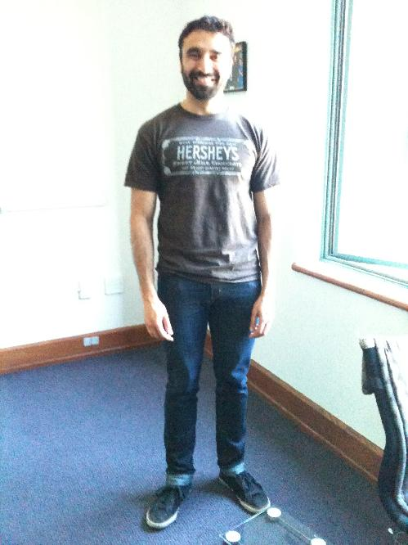

Q15 How much does this person weigh? (in pounds)

Q17
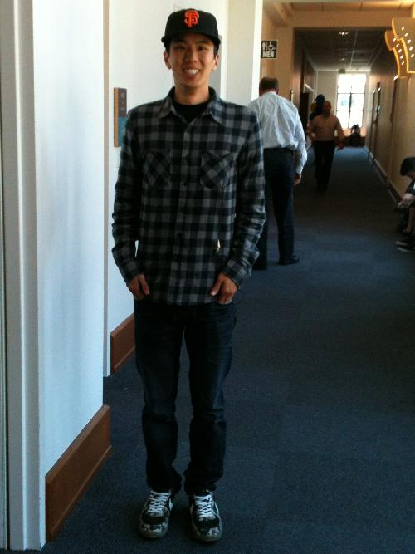

Q19 How much does this person weigh? (in pounds)

Q21
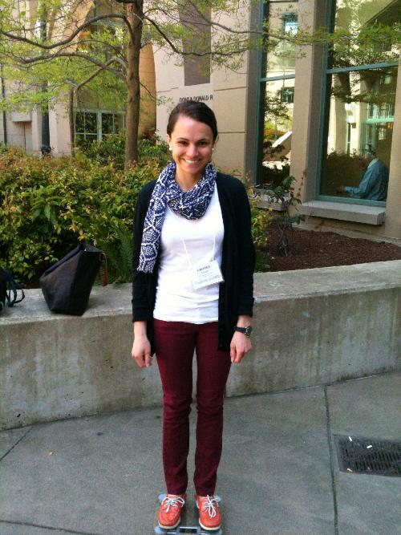

Q23 How much does this person weigh? (in pounds)

Q25
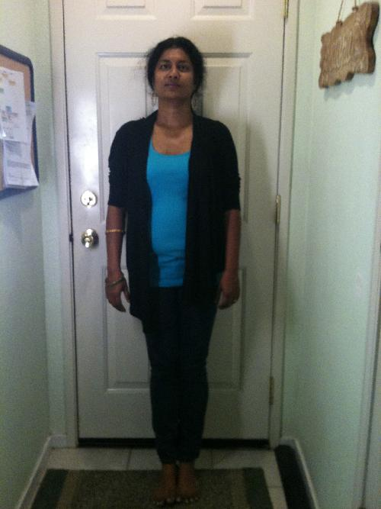

Q27 How much does this person weigh? (in pounds)

Q29
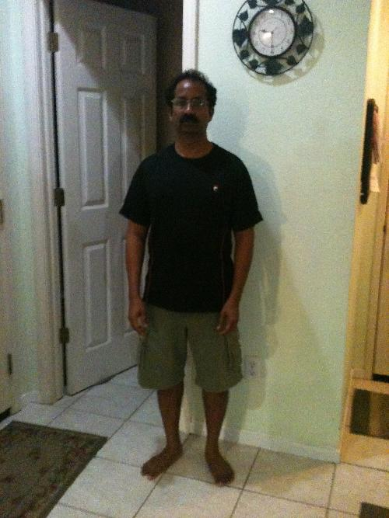

Q31 How much does this person weigh? (in pounds)

Q33
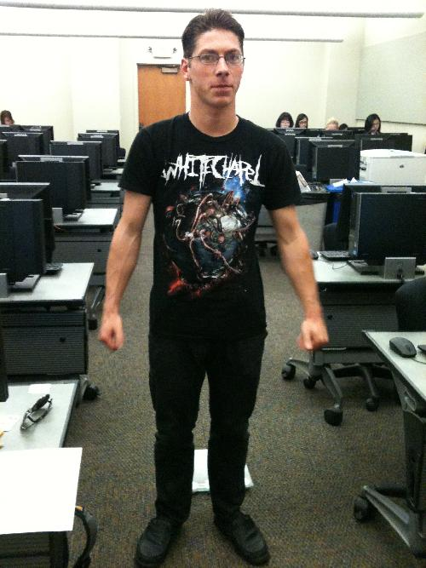

Q35 How much does this person weigh? (in pounds)

Q37

Q39 How much does this person weigh? (in pounds)

Q41
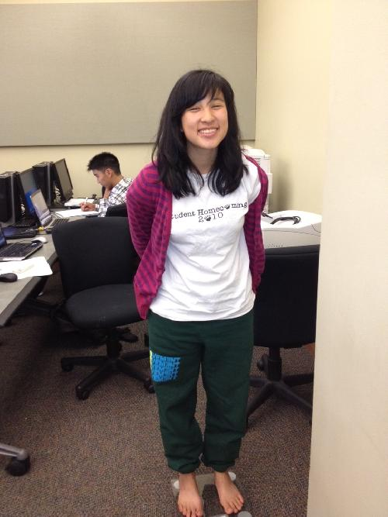

Q43 How much does this person weigh? (in pounds)

Q45
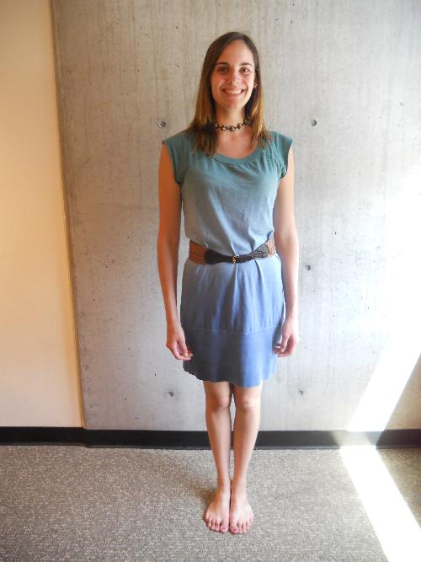

Q47 How much does this person weigh? (in pounds)

Q49
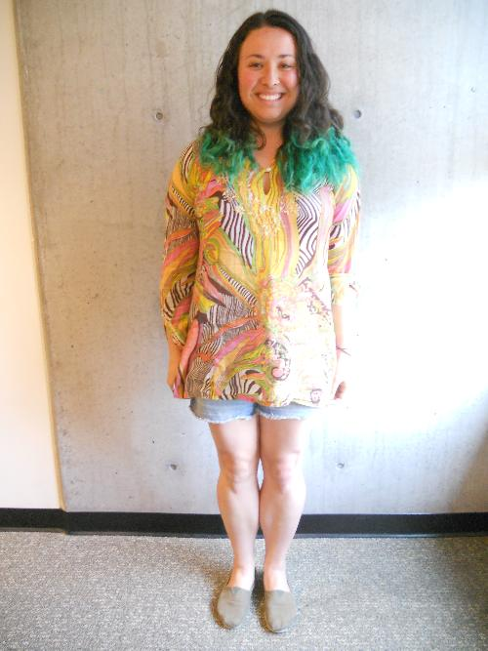

Q51 How much does this person weigh? (in pounds)

Q52 Remember that an answer counts as correct if it is within 40 pounds of the right answer. We want to know how you think you did. Please tell us how likely it is that you got each of the possible scores below on the survey by dragging the bar to the desired location.
______ Zero right (1)
______ 1 right, 9 wrong (2)
______ 2 right, 8 wrong (3)
______ 3 right, 7 wrong (4)
______ 4 right, 6 wrong (5)
______ 5 right, 5 wrong (6)
______ 6 right, 4 wrong (7)
______ 7 right, 3 wrong (8)
______ 8 right, 2 wrong (9)
______ 9 right, 1 wrong (10)
______ All 10 right (11)

Q45 As an incentive to answer this question accurately, we will be rewarding accurate responses using the quadratic scoring rule. For more details, click here.

Q54 We have randomly selected one other participant out of the large number of people who have also completed this survey. Please tell us how you think that person did. Specifically, we need you to tell us how likely it is that that randomly selected person got each of the possible scores below.
Click in the empty space to create a bar, and drag it to the desired location.
______ Zero right (1)
______ 1 right, 9 wrong (2)
______ 2 right, 8 wrong (3)
______ 3 right, 7 wrong (4)
______ 4 right, 6 wrong (5)
______ 5 right, 5 wrong (6)
______ 6 right, 4 wrong (7)
______ 7 right, 3 wrong (8)
______ 8 right, 2 wrong (9)
______ 9 right, 1 wrong (10)
______ All 10 right (11)

Q47 As an incentive to answer this question accurately, we will be rewarding accurate responses using the quadratic scoring rule. For more details, click here.

Q174 This task is now complete, please continue.

Q57 You will be guessing the weights of 10 different people. If your guess is within 3 pounds of the actual weight, it is considered a "correct" answer. An answer 4 or more pounds away from the actual weight will be considered "incorrect". If you think in kilograms, recall that there are 2.2 lbs per kilogram.
Proceed to the next page to start guessing weights.

Q42 Before you move on to the survey on the next page, we want to check whether you have paid attention to the details and directions we gave you in the previous pages.Please answer the following questions to move on to the weight-guessing task. If you do not answer the following questions correctly, you will not be able to move forward and finish the task.

Q43 How many people will you be guessing the weights of?

Q44 How many pounds do you have to guess within the actual weight in order for your answer to be considered "correct"?

Q59 Remember that an answer counts as correct if it is within 3 pounds of the right answer. We want to know how you think you did. Please tell us how likely it is that you got each of the possible scores below on the survey by dragging the bar to the desired location.
______ Zero right (1)
______ 1 right, 9 wrong (2)
______ 2 right, 8 wrong (3)
______ 3 right, 7 wrong (4)
______ 4 right, 6 wrong (5)
______ 5 right, 5 wrong (6)
______ 6 right, 4 wrong (7)
______ 7 right, 3 wrong (8)
______ 8 right, 2 wrong (9)
______ 9 right, 1 wrong (10)
______ All 10 right (11)

Q46 As an incentive to answer this question accurately, we will be rewarding accurate responses using the quadratic scoring rule. For more details, click here.

Q54 In this task, you will be giving estimates of the unit area of ten geometric shapes. There will be a square pictured to the right of each shape. You should use this as a representation of a single unit in your estimates.
You will only be able to see the shape for five seconds. It will disappear and then you will be asked the following questions for each shape:
"Enter a number so LOW that there is only a 5% chance that the area of the shape is that number or less"
-AND-
"Enter a number so HIGH that there is only a 5% chance that the area of the shape is that number or more"
Once you submit your answers, you will be immediately directed to the next shape.

Q55 Once again, you will be rewarded for accurate estimates, so please estimate to the best of your ability.

Q57 Before you move on to the survey on the next page, we want to check whether you have paid attention to the details and directions we gave you in the previous page.Please answer the following question to move on to the geometric unit area guessing task. If you do not answer the following question correctly, you will not be able to move forward and finish the task.

Q56 How many seconds do you have to look at the shape?

Q163 The following is an example of the type of answers we are looking for in response to the geometric shape questions:

Q175 Timing
First Click (1)
Last Click (2)
Page Submit (3)
Click Count (4)

Q164 Participant A was shown the following shape for 5 seconds:
Participant A thought that the shape had around __# of units contained within it.
When we asked Participant A the question &quot;Enter a number so LOW that there is only a 5% chance that the area of the shape is that number or less&quot;, he responded with __# because he thought that there was only a 5% chance the shape had less than __# of units in it.
When we asked Participant A the question &quot;Enter a number so HIGH that there is only a 5% chance the area of the shape is that number or more&quot;, he responded with __# because he thought that there was only a 5% chance the shape had more than __# of units in it.

Q165 Do you understand what the questions are asking for the geometric shape task?
- Yes (1)
- No (2)

Q127 Remember you will only be able to see the shape for five seconds and then will be asked:
&quot;Enter a number so LOW that there is only a 5% chance that the area of the shape is that number or less&quot;
-AND-
&quot;Enter a number so HIGH that there is only a 5% chance that the area of the shape is that number or more&quot;
Continue on once you are ready to view the first shape.

Q125 Timing
First Click (1)
Last Click (2)
Page Submit (3)
Click Count (4)

Q61

Q60 Please answer the following questions about the shape you just saw:

Q148 Enter a number so LOW that there is only a 5% chance that the area of the shape is that number or less:

Q124 Enter a number so HIGH that there is only a 5% chance that the area of the shape is that number or more:

Q128 Timing
First Click (1)
Last Click (2)
Page Submit (3)
Click Count (4)

Q64

Q129 Please answer the following questions about the shape you just saw:

Q130 Enter a number so LOW that there is only a 5% chance that the area of the shape is that number or less:

Q131 Enter a number so HIGH that there is only a 5% chance that the area of the shape is that number or more:

Q132 Timing
First Click (1)
Last Click (2)
Page Submit (3)
Click Count (4)

Q67

Q146 Please answer the following questions about the shape you just saw:

Q155 Enter a number so LOW that there is only a 5% chance that the area of the shape is that number or less:

Q161 Enter a number so HIGH that there is only a 5% chance that the area of the shape is that number or more:

Q136 Timing
First Click (1)
Last Click (2)
Page Submit (3)
Click Count (4)

Q70

Q145 Please answer the following questions about the shape you just saw:

Q154 Enter a number so LOW that there is only a 5% chance that the area of the shape is that number or less:

Q160 Enter a number so HIGH that there is only a 5% chance that the area of the shape is that number or more:

Q135 Timing
First Click (1)
Last Click (2)
Page Submit (3)
Click Count (4)

Q73

Q144 Please answer the following questions about the shape you just saw:

Q153 Enter a number so LOW that there is only a 5% chance that the area of the shape is that number or less:

Q159 Enter a number so HIGH that there is only a 5% chance that the area of the shape is that number or more:

Q134 Timing
First Click (1)
Last Click (2)
Page Submit (3)
Click Count (4)

Q76

Q140 Please answer the following questions about the shape you just saw:

Q152 Enter a number so LOW that there is only a 5% chance that the area of the shape is that number or less:

Q158 Enter a number so HIGH that there is only a 5% chance that the area of the shape is that number or more:

Q133 Timing
First Click (1)
Last Click (2)
Page Submit (3)
Click Count (4)

Q79

Q143 Please answer the following questions about the shape you just saw:

Q151 Enter a number so LOW that there is only a 5% chance that the area of the shape is that number or less:

Q157 Enter a number so HIGH that there is only a 5% chance that the area of the shape is that number or more:

Q139 Timing
First Click (1)
Last Click (2)
Page Submit (3)
Click Count (4)

Q82

Q142 Please answer the following questions about the shape you just saw:

Q62 Enter a number so LOW that there is only a 5% chance that the area of the shape is that number or less:

Q156 Enter a number so HIGH that there is only a 5% chance that the area of the shape is that number or more:

Q138 Timing
First Click (1)
Last Click (2)
Page Submit (3)
Click Count (4)

Q85

Q141 Please answer the following questions about the shape you just saw:

Q149 Enter a number so LOW that there is only a 5% chance that the area of the shape is that number or less:

Q162 Enter a number so HIGH that there is only a 5% chance that the area of the shape is that number or more:

Q137 Timing
First Click (1)
Last Click (2)
Page Submit (3)
Click Count (4)

Q88

Q147 Please answer the following questions about the shape you just saw:

Q150 Enter a number so LOW that there is only a 5% chance that the area of the shape is that number or less:

Q163 Enter a number so HIGH that there is only a 5% chance that the area of the shape is that number or more:

Q187 Now we want to know how you think you did. Please tell us how likely it is that you got each of the possible scores below on the survey by dragging the bar to the desired location.A "right" answer means that the actual area of the shape was included the the range you gave.
______ Zero right (1)
______ 1 right, 9 wrong (2)
______ 2 right, 8 wrong (3)
______ 3 right, 7 wrong (4)
______ 4 right, 6 wrong (5)
______ 5 right, 5 wrong (6)
______ 6 right, 4 wrong (7)
______ 7 right, 3 wrong (8)
______ 8 right, 2 wrong (9)
______ 9 right, 1 wrong (10)
______ All 10 right (11)

Q188 As an incentive to answer this question accurately, we will be rewarding accurate responses using the quadratic scoring rule. For more details, click here.

Q191 We have randomly selected one other participant out of the large number of people who have also completed this survey. Please tell us how you think that person did. Specifically, we need you to tell us how likely it is that that randomly selected person got each of the possible scores below.
Click in the empty space to create a bar, and drag it to the desired location.Remember that a "right" answer means that the actual area of the shape was within the range provided by the participant.
______ Zero right (1)
______ 1 right, 9 wrong (2)
______ 2 right, 8 wrong (3)
______ 3 right, 7 wrong (4)
______ 4 right, 6 wrong (5)
______ 5 right, 5 wrong (6)
______ 6 right, 4 wrong (7)
______ 7 right, 3 wrong (8)
______ 8 right, 2 wrong (9)
______ 9 right, 1 wrong (10)
______ All 10 right (11)

Q192 As an incentive to answer this question accurately, we will be rewarding accurate responses using the quadratic scoring rule. For more details, click here.

Q91 In this task, you will be giving estimates of the percentage of black dots to the total number of dots in a given image.
You will only be able to see the image for five seconds. It will disappear and then you will be asked the following questions for each image:
"Enter a number so LOW that there is only a 5% chance that the percentage of black dots is that number or less"
-AND-
"Enter a number so HIGH that there is only a 5% chance that the percentage of black dots is that number or more"
Once you submit your answers, you will be immediately directed to the next image.

Q167 Please answer the following question in order to move onto the dot task. If you do not answer the following questions correctly, you will not be able to move forward and finish the task.

Q122 What is the color of the dots you will be providing estimates for?
- Black (1)
- Green (2)

Q166 Timing
First Click (1)
Last Click (2)
Page Submit (3)
Click Count (4)

Q167 Participant A was shown the following image for 5 seconds:
Participant A thought that __% of the dots in the picture were black.
When we asked Participant A the question "Enter a number so LOW that there is only a 5% chance that the percentage of black dots is that number or less", he responded with __% because he thought that there was only a 5% chance the image had less than __% of black dots in it.
When we asked Participant A the question "Enter a number so HIGH that there is only a 5% chance that the percentage of black dots is that number or more", he responded with __% because he thought that there was only a 5% chance the image had more than __% of black dots in it.

Q168 Which of the following will you be estimating?
- Number of Black Dots (1)
- Percentage of Black Dots (3)

Q174 You failed the attention check. Please review the information for this task once more, and then attempt the attention check again.

Q189 Remember you will only be able to see the image for five seconds and then you will be asked:
"Enter a number so LOW that there is only a 5% chance that the percentage of black dots is that number or less"-AND-"Enter a number so HIGH that there is only a 5% chance that the percentage of black dots is that number or more"
Continue on once you are ready to view the first image.

Q92 Timing
First Click (1)
Last Click (2)
Page Submit (3)
Click Count (4)

Q93

Q176 Please answer the following questions about the image you just saw:

Q94 Enter a number so LOW that there is only a 5% chance that the percentage of black dots is that number or less:

Q175 Enter a number so HIGH that there is only a 5% chance that the percentage of black dots is that number or more:

Q118 Timing
First Click (1)
Last Click (2)
Page Submit (3)
Click Count (4)

Q119

Q184 Please answer the following questions about the image you just saw:

Q194 Enter a number so LOW that there is only a 5% chance that the percentage of black dots is that number or less:

Q203 Enter a number so HIGH that there is only a 5% chance that the percentage of black dots is that number or more:

Q121 Timing
First Click (1)
Last Click (2)
Page Submit (3)
Click Count (4)

Q122

Q183 Please answer the following questions about the image you just saw:

Q195 Enter a number so LOW that there is only a 5% chance that the percentage of black dots is that number or less:

Q204 Enter a number so HIGH that there is only a 5% chance that the percentage of black dots is that number or more:

Q124 Timing
First Click (1)
Last Click (2)
Page Submit (3)
Click Count (4)

Q125

Q182 Please answer the following questions about the image you just saw:

Q192 Enter a number so LOW that there is only a 5% chance that the percentage of black dots is that number or less:

Q202 Enter a number so HIGH that there is only a 5% chance that the percentage of black dots is that number or more:

Q127 Timing
First Click (1)
Last Click (2)
Page Submit (3)
Click Count (4)

Q128

Q181 Please answer the following questions about the image you just saw:

Q193 Enter a number so LOW that there is only a 5% chance that the percentage of black dots is that number or less:

Q201 Enter a number so HIGH that there is only a 5% chance that the percentage of black dots is that number or more:

Q130 Timing
First Click (1)
Last Click (2)
Page Submit (3)
Click Count (4)

Q131

Q179 Please answer the following questions about the image you just saw:

Q191 Enter a number so LOW that there is only a 5% chance that the percentage of black dots is that number or less:

Q200 Enter a number so HIGH that there is only a 5% chance that the percentage of black dots is that number or more:

Q133 Timing
First Click (1)
Last Click (2)
Page Submit (3)
Click Count (4)

Q134

Q180 Please answer the following questions about the image you just saw:

Q190 Enter a number so LOW that there is only a 5% chance that the percentage of black dots is that number or less:

Q199 Enter a number so HIGH that there is only a 5% chance that the percentage of black dots is that number or more:

Q136 Timing
First Click (1)
Last Click (2)
Page Submit (3)
Click Count (4)

Q137

Q177 Please answer the following questions about the image you just saw:

Q189 Enter a number so LOW that there is only a 5% chance that the percentage of black dots is that number or less:

Q197 Enter a number so HIGH that there is only a 5% chance that the percentage of black dots is that number or more:

Q139 Timing
First Click (1)
Last Click (2)
Page Submit (3)
Click Count (4)

Q140

Q178 Please answer the following questions about the image you just saw:

Q188 Enter a number so LOW that there is only a 5% chance that the percentage of black dots is that number or less:

Q198 Enter a number so HIGH that there is only a 5% chance that the percentage of black dots is that number or more:

Q142 Timing
First Click (1)
Last Click (2)
Page Submit (3)
Click Count (4)

Q143

Q185 Please answer the following questions about the image you just saw:

Q187 Enter a number so LOW that there is only a 5% chance that the percentage of black dots is that number or less:

Q196 Enter a number so HIGH that there is only a 5% chance that the percentage of black dots is that number or more:

Q195 Now we want to know how you think you did. Please tell us how likely it is that you got each of the possible scores below on the survey by dragging the bar to the desired location.A "right" answer means that the actual percentage of black dots in the image was included the the range you gave.
______ Zero right (1)
______ 1 right, 9 wrong (2)
______ 2 right, 8 wrong (3)
______ 3 right, 7 wrong (4)
______ 4 right, 6 wrong (5)
______ 5 right, 5 wrong (6)
______ 6 right, 4 wrong (7)
______ 7 right, 3 wrong (8)
______ 8 right, 2 wrong (9)
______ 9 right, 1 wrong (10)
______ All 10 right (11)

Q196 As an incentive to answer this question accurately, we will be rewarding accurate responses using the quadratic scoring rule. For more details, click here.

Q193 We have randomly selected one other participant out of the large number of people who have also completed this survey. Please tell us how you think that person did. Specifically, we need you to tell us how likely it is that that randomly selected person got each of the possible scores below.
Click in the empty space to create a bar, and drag it to the desired location.Remember that a "right" answer means that the actual percentage of black dots in the image was within the range provided by the participant.
______ Zero right (1)
______ 1 right, 9 wrong (2)
______ 2 right, 8 wrong (3)
______ 3 right, 7 wrong (4)
______ 4 right, 6 wrong (5)
______ 5 right, 5 wrong (6)
______ 6 right, 4 wrong (7)
______ 7 right, 3 wrong (8)
______ 8 right, 2 wrong (9)
______ 9 right, 1 wrong (10)
______ All 10 right (11)

Q194 As an incentive to answer this question accurately, we will be rewarding accurate responses using the quadratic scoring rule. For more details, click here.

Q73 In what year were you born?

Q68 How old are you?
. (1)

Q70 What is your sex?
- Female (1)
- Male (2)

Q72 Anything else you would like to tell us about this survey or your answers?

